**Scenario:**

Fixing a file based on the error messages provided and revalidates it.

1) Error

2) User starts fixing the error by using their preferred text editor.

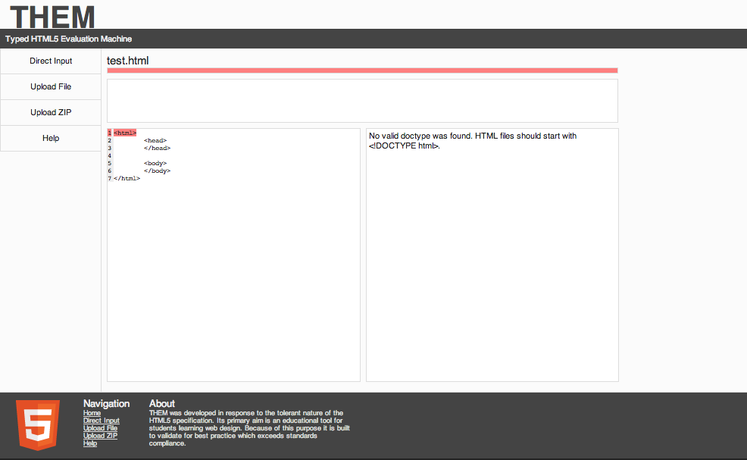

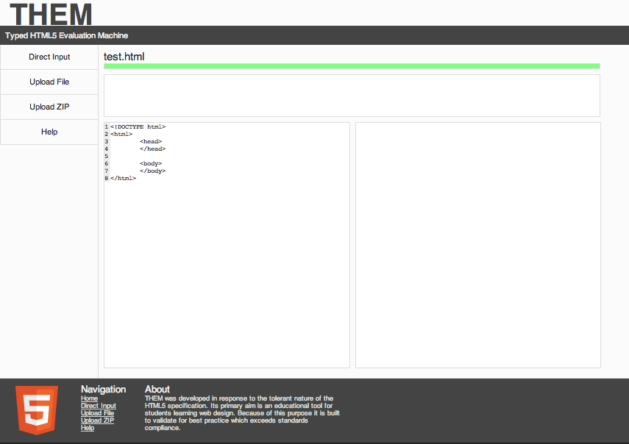3) The HTML has been fixed and resubmitted.

**Scenario:**

Uploading a zipped website and validate it for errors.

1. Navigate to the upload zip tab.

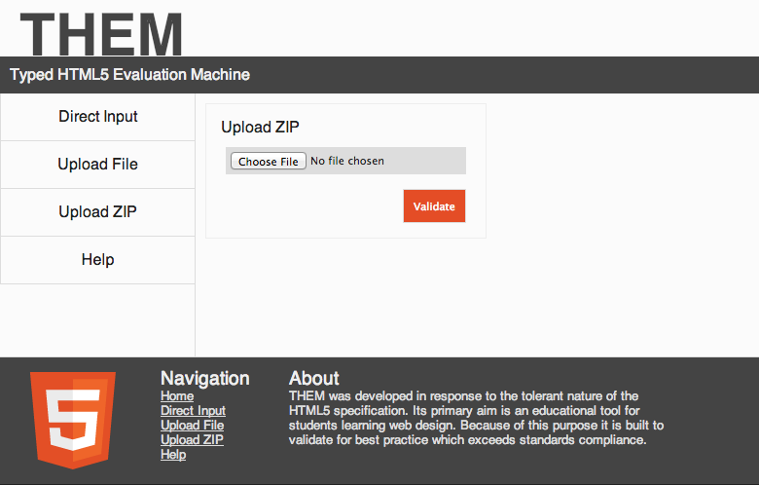

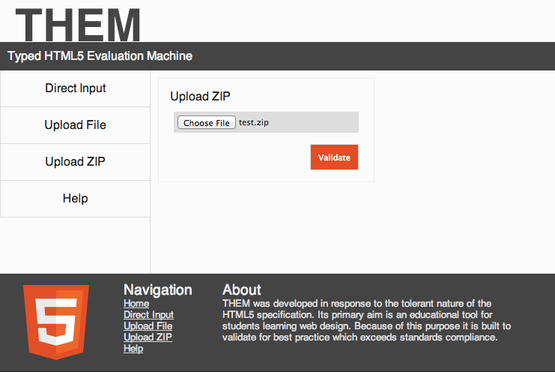2) Zipped website is added.

1. The zipped has been validated.

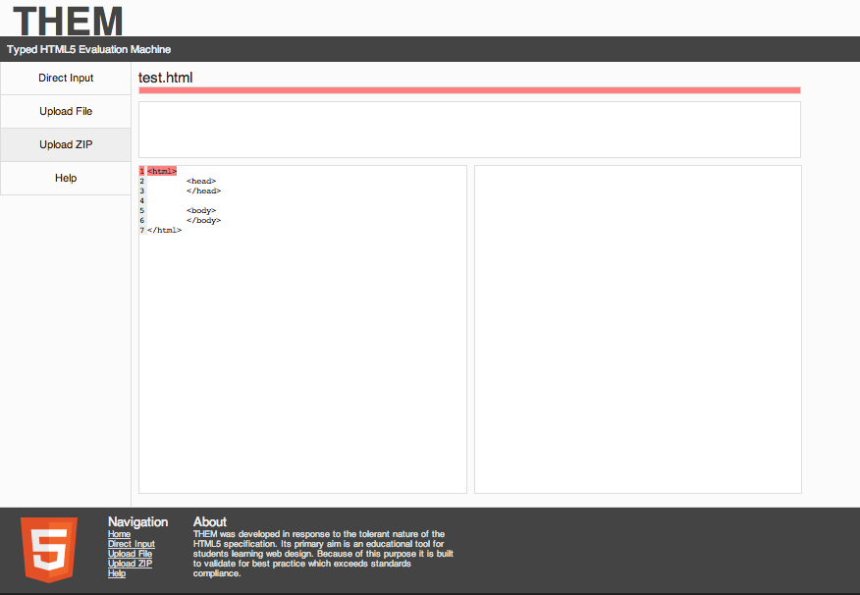

**Scenario:**

Upload any non-HTML file type.

1) Added a non-HTML file, in this case, it is a PDF file.

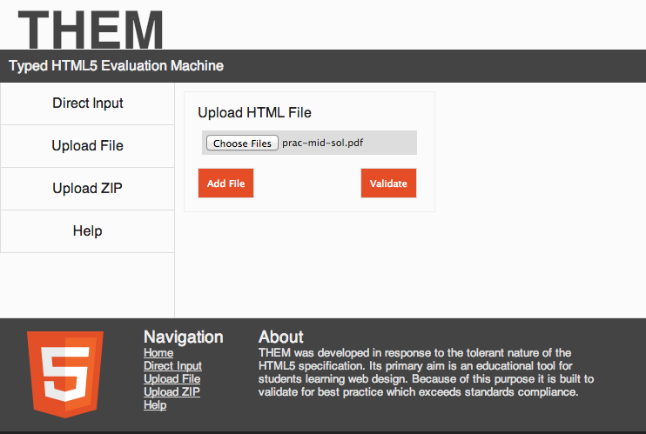

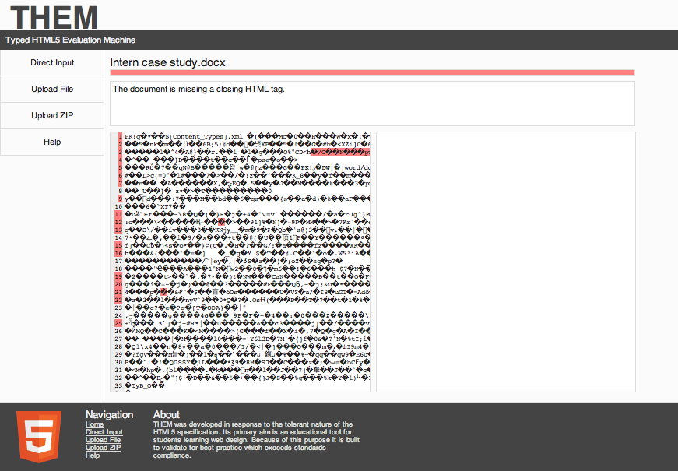

2) Validated the non-HTML file